***Lecture Two − Techniques of Integration***

***Section* 2.1 – Integration by Parts**

Integration by parts is a technique for simplifying integrals of the form



***Example***: 

**Integration by Parts Formula**



Let *u* and *v* be differentiable functions of *x*. 

**Guidelines for integration by Parts**

1. Let *dv* be the most complicated portion of the integrand that fits a basic integration formula. Let *u* be the remaining factor.
2. Let *u* be the portion of the integrand whose derivative is a function simpler than *u*. Let *dv* be the remaining factor.

***Example***

Evaluate: 

***Solution***

***Let***: 

 



***Example***

Evaluate: 

***Solution***

Let:



 





**Tabular Integration**

***Example***

Evaluate 

***Solution***

|  |  |  |  |  |  |  |  |  |  |  |  |  |  |
| --- | --- | --- | --- | --- | --- | --- | --- | --- | --- | --- | --- | --- | --- |
| |  |  |  | | --- | --- | --- | | **&**  **derivatives** |  |  | |  |  |  | |  |  |  | |  |  |  |   It is called ***tabular integration*** | Let: |

***Example***

|  |  |  |
| --- | --- | --- |
|  | |  |
| **+** |  |  |
| **−** |  |  |
| **+** |  |  |
| **−** |  |  |

Evaluate 

***Solution***



***Example***

Evaluate 

***Solution***

|  |  |  |  |  |  |  |  |  |  |  |  |  |  |
| --- | --- | --- | --- | --- | --- | --- | --- | --- | --- | --- | --- | --- | --- |
|  | |  |  |  | | --- | --- | --- | |  |  |  | | **+** |  |  | | **-** |  |  | | **+** |  |  | |

Let: 

 Let: 













***Example***

Obtain a formula that expresses the integral 

***Solution***

Let: 





















***Example:*** 



**Evaluating Definite Integrals by Parts**

***Example***

Find the area of the region bounded by the curve  and the *x*-axis from *x* = 0 to *x* = 4.

***Solution***

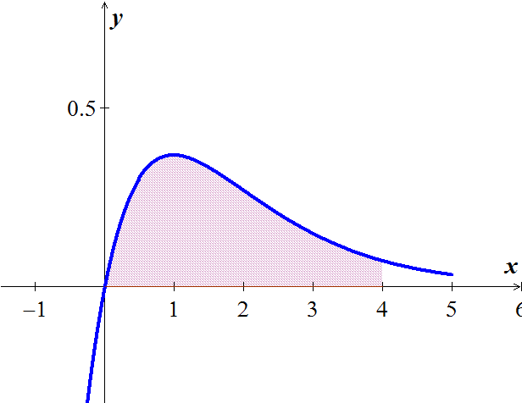

|  |  |  |
| --- | --- | --- |
|  |  |  |
| + |  |  |
| − |  |  |







**2nd *Method***

Let:  















***Formula***

Evaluate 

|  |  |  |
| --- | --- | --- |
|  |  |  |
| **+** |  |  |
| **−** |  |  |
| **+** |  |  |
| **−** |  |  |
|  |  |  |





***Exercises*** ***Section* 2.1 – Integration by Parts**

Evaluate the integrals

|  |  |  |
| --- | --- | --- |
|  |  |  |

|  |  |  |
| --- | --- | --- |
|  |  |  |

1. Find the volume of the solid generated by revolving the region in the first quadrant bounded by the coordinate aces, the cure , and the line  about the line 
2. Find the volume of the solid generated by revolving the region in the first quadrant bounded by the coordinate axes, the cure , and the line , about
3. the line 
4. the line 
5. Find the volume of the solid that is generated by the region bounded by , and the coordinate axes is revolved about the .
6. Find the volume of the solid that is generated by the region bounded by , and the  on  is revolved about the .
7. Find the area of the region generated when the region bounded by  and  on the interval .
8. Find the area between the curves 

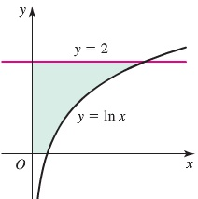

1. Determine the area of the shaded region bounded by



1. The curves  are shown in the figure for .

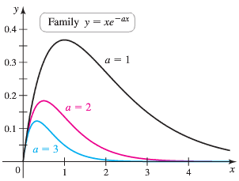

1. Find the area of the region bounded by  and the *x-*axis on the interval [0, 4].
2. Find the area of the region bounded by  and the *x-*axis on the interval [0, 4] where 
3. Find the area of the region bounded by  and the *x-*axis on the interval [0, *b*]. Because this area depends on *a* and *b*, we call it where  and .
4. Use part (*c*) to show that 
5. Does this pattern continue? Is it true that 
6. Suppose a mass on a spring that is slowed by friction has the position function 
7. Graph the position function. At what times does the oscillator pass through the position ?
8. Find the average value of the position on the interval .
9. Generalize part (*b*) and find the average value of the position on the interval , for 
10. Given the region bounded by the graphs of , find
11. The area of the region.
12. The volume of the solid generated by revolving the region about the 
13. The volume of the solid generated by revolving the region about the 
14. The centroid of the region

***Section* 2.2 – Trigonometric Integrals**

**Products of Powers of *Sines* and *Cosines***

We begin with integrals of the form



***Example***

Evaluate 

***Solution***



 

 





***Example***

Evaluate 

***Solution***

  







***Example***

Evaluate 

***Solution***

 



























***Example***

Evaluate 

***Solution***





 

 









***Example***

Evaluate 

***Solution***











**Products of Powers of *tan x* and *sec x***

***Example***

Evaluate 

***Solution***

 









 



***Example***

Evaluate 

***Solution***

Let: 



















**Products of Sines and Cosines**

Recall the identities







***Example***

Evaluate 

***Solution***









**Guidelines for Cosine & Sine**

***Case* 1** If ***m*** is ***odd***, we write *m* as  and use the identity  to obtain



Then we combine the single  with  in the integral and set 

***Case* 2** If ***m*** is ***even* and *n*** is ***odd***, in  we write *n* as  and use the identity  to obtain



Then we combine the single  with  in the integral and set 

***Case* 3** If both ***m*** **and *n*** are ***even***, in , we substitute

To reduce the integrand to one in lower powers of  

**Guidelines for Tangent & Secant**

***Case* 1** When the power of the tangent is ***odd*** and positive.





***Case* 2** When the power of the secant is ***even*** and positive.



***Case* 3** When there are no secant factors



***Case* 4** When there are only secant, use integration by parts.

***Case* 5** Otherwise, convert to cosines and sines.

***Wallis’s Formulas***

|  |
| --- |
| 1. If *n* is odd , then 2. If *n* is even , then |

***Formulas***















***Exercises*** ***Section* 2.2 – Trigonometric Integrals**

Evaluate the integrals

|  |  |  |
| --- | --- | --- |
|  |  |  |

|  |  |  |
| --- | --- | --- |
|  |  |  |

1. Find the area of the region bounded by the graphs of  and  on the interval 

Find the area of the region bounded by the graphs of the equations

1. 
2. 
3. 
4. 

Find the volume of the solid generated by revolving the region bounded by the graphs of the equations about the 

|  |  |
| --- | --- |
|  |  |

Find the ***volume*** of the solid generated by revolving the region bounded by the graphs of the equations about the , then find the ***centroid*** of the region

|  |  |
| --- | --- |
|  |  |

***Section* 2.3 – Trigonometric Substitutions**

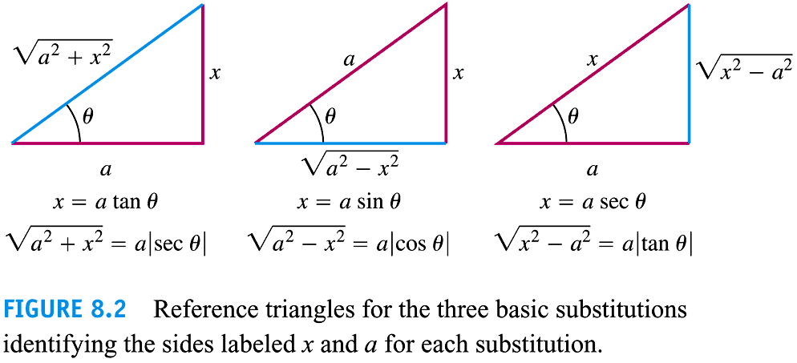







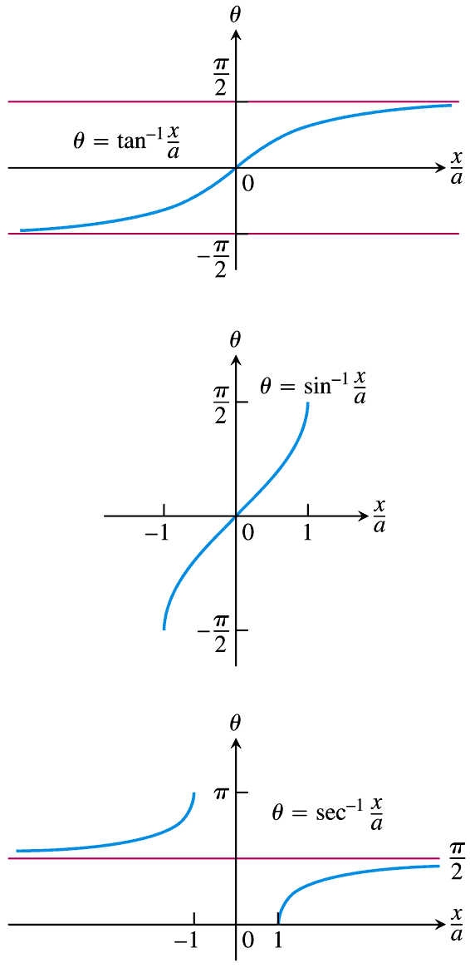



**Procedure for a Trigonometric Substitution**

1. Write down the substitution for *x*, calculate the differential *dx*, and specify the selected values of *θ* for the substitution.
2. Substitute the trigonometric expression and the calculated differential into the integrand, and then simplify the results algebraically.
3. Integrate the trigonometric integral, keeping in mind the restrictions on the angle *θ* for reversibility.
4. Draw an appropriate reference triangle to reserve the substitution in the integration result and convert it back to the original variable *x*.

***Example***

Evaluate 

***Solution***

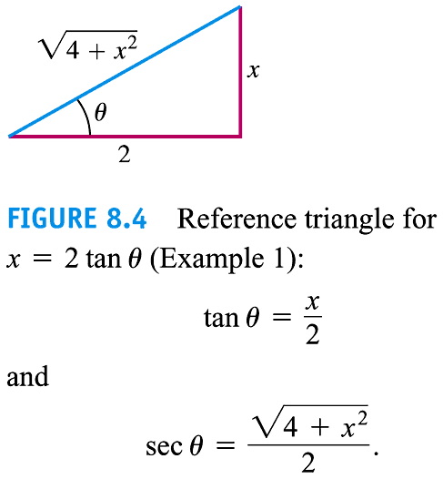Let: 

















***Example***

Evaluate 

**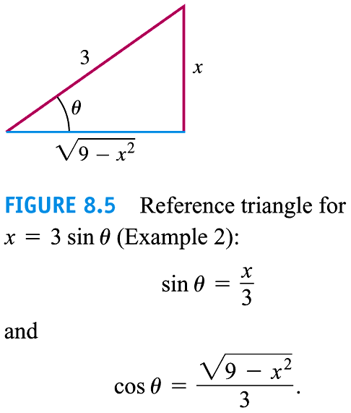*Solution***















 

 





***Example***

Evaluate 

**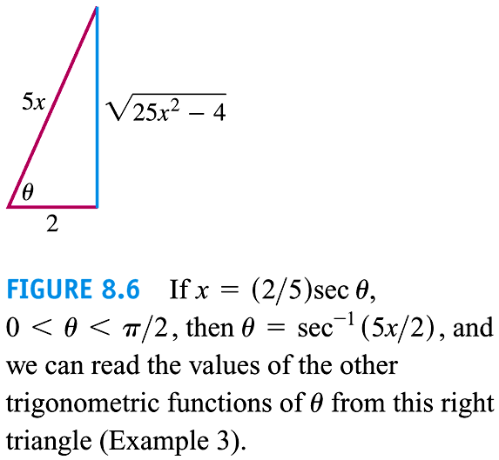*Solution***























***Exercises*** ***Section* 2.3 – Trigonometric Substitutions**

Evaluate the integrals

|  |  |  |
| --- | --- | --- |
|  |  |  |

|  |  |  |
| --- | --- | --- |
|  |  |  |

1. Consider the region bounded by the graph  and *y* = 0 for . Find the volume of the solid formed by revolving this region about the *x*-axis.

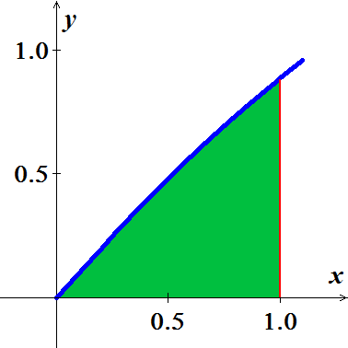

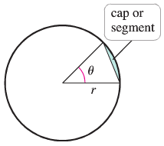

1. Use two approach to show that the area of a cap (or segment) of a circle of radius *r* subtended by an angle *θ* is given by



1. Find the area using geometry (no calculus).
2. Find the area using calculus
3. A lune is a crescent-shaped region bounded by the arcs of two circles. Let  be a circle of radius 4 centered at the origin. Let  be a circle of radius 3 centered at the point . Find the area of the lune that lies inside  and outside .

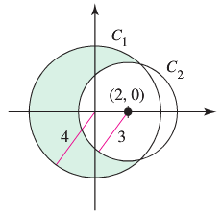

1. The crescent-shaped region bounded by two circles forms a lune. Find the area of the lune given that the radius of the smaller circle is 3 and the radius of the larger circle is 5.

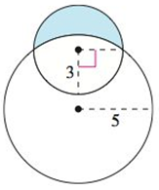

1. Consider the function  and the region ***R*** on the interval [0, 4].
2. Find the area of *R*.
3. Find the volume of the solid generated when *R* is revolved about the .
4. Find the volume of the solid generated when *R* is revolved about the .

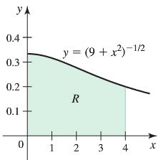

1. A total of ***Q*** is distributed uniformly on a line segment of length 2*L* along the . The *x-*component of the electric field at a point  is given by



|  |  |
| --- | --- |
| Where *k* is a physical constant and   1. Confirm that 2. Letting  be the charge density on the line segment, show that if |  |

1. A long, straight wire of length 2*L* on the *y-axis* carries a current *I*. according to the Biot-Savart Law, the magnitude of the field due to the current at a point  is given by



Where  is a physical constant, , and *θ*, *r*, and *y* are related to the figure

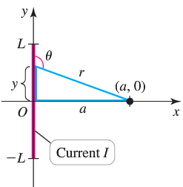

1. Show that the magnitude of the magnetic field at  is 
2. What is the magnitude of the magnetic field at  due to an infinitely long wire ?
3. The cycloid is the curve traced by a point on the rim of a rolling wheel. Imagine a wire shaped like an inverted cycloid.

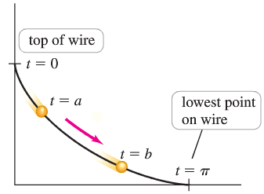

A bead sliding down this wire without friction has some remarkable properties. Among all wire shapes, the cycloid is the shape that produces the fastest descent time. It can be shown that the descent time between any two points  on the curve is



Where *g* is the acceleration due to gravity,  corresponds to the top of the wire, and  corresponds to the lowest point on the wire.

1. Find the descent time on the interval .
2. Show that when , the descent time is the same for all values of *a*; that is, the descent time to the bottom of the wire is the same for all starting points.
3. Find the area of the region bounded by the curve and the  on the interval 
4. Find the length of the curve from  to , where  is a real number.
5. Find the arc length of the graph of  from  to 
6. A projectile is launched from the ground with an initial speed *V* at an angle  from the horizontal. Assume that the  is the horizontal ground and *y* is the height above the ground. Neglecting air resistance and letting *g* be the acceleration due to gravity, it can be shown that the trajectory of the projectile is given by



1. Note that the high point of the trajectory occurs at . If the projectile is on the ground at  and , what is *a*?
2. Show that the length of the trajectory (arc length) is 
3. Evaluate the arc length integral and express your result in the terms of *V, g*, and .
4. For fixed value of *V* and *g*, show that the launch angle  that maximizes the length of the trajectory satisfies 
5. Let . The figure shows that



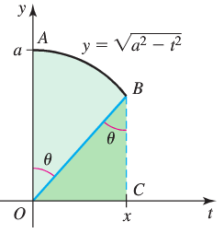

1. Use the figure to prove that 
2. Conclude that 
3. A sealed barrel of oil (weighing *48 pounds per cubic foot) is floating in seawater (weighing 64 pounds per cubic foot). The barrel is not completely full of oil. With the barrel lying on its side, the top 0.2 *foot* of the barrel is empty.

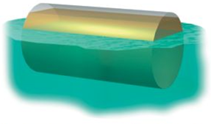 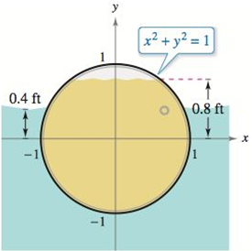

Compare the fluid forces against one end of the barrel from the inside and from the outside.

1. The axis of a storage tank in the form of a right circular cylinder is horizontal. The radius and length of the tank are 1 *meter* and 3 *meters*, respectively.

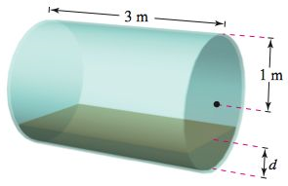

1. Determine the volume of fluid in the tank as a function of its depth *d*.
2. Graph the function in part (*a*).
3. Design a dip stick for the tank with markings of 
4. Fluid is entering the tank at a rate of . Determine the rate of change of the depth of the fluid as a function of its depth *d*.
5. Graph the function in part (*d*).\When will the rate of change of the depth be minimum?
6. The surface of a machine part is the region between the graphs of 

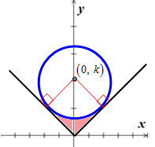

1. Find *k* when the circle is tangent to the graph of 
2. Find the area of the surface of the machine part.
3. Find the area of the surface of the machine part as a function of the radius *r* of the circle.
4. 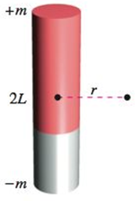The field strength *H* of a magnet of length 2*L* on a particle *r* units from the center of the magnet is



Where  are the poles of the magnet.

Find the average field strength as the particle moves from 0 to *R* units from the center by evaluating the integral



***Section* 2.4 – Partial Fractions**

This section shows how to express a rational; function as a sum of simpler functions, called ***partial fractions***.

***Example***

Evaluate 

***Solution***



 





***Example***

Use partial fractions to evaluate 

***Solution***















**Method of Partial Fractions** 

1. Let be a linear factor of . Suppose that  is the highest power of  that divides . Then,



1. Let  be an irreducible quadratic function of  has no real roots. Suppose that  is the highest power. Then



1. Set the original fraction  equal to the sum of these partial fractions.
2. Equate the coefficients of corresponding powers of *x* and solve the resulting equations for the undetermined coefficients.

***Example***

Use partial fractions to evaluate 

***Solution***









 





***Example***

Use partial fractions to evaluate 

***Solution***

|  |  |
| --- | --- |
|  |  |

 







***Example***

Use partial fractions to evaluate 

***Solution***

















***Example***

Use partial fractions to evaluate 

***Solution***











 











***Exercises*** ***Section* 2.4 – Partial Fractions**

Express the integrand as a sum of partial fractions and evaluate the integrals

|  |  |  |  |
| --- | --- | --- | --- |
|  | |  | |
|  |  | |  | |

1. Find the volume of the solid generated by the revolving the shaded region about *x*-axis



Find the area of the region bounded by the graphs of

|  |  |
| --- | --- |
|  |  |

1. Consider the region bounded by the graphs .
2. Find the volume of the solid generated by revolving the region about the 
3. Find the centroid of the region.
4. Consider the region bounded by the graph .

Find the volume of the solid generated by revolving this region about the .

1. A single infected individual enters a community of *n* susceptible individuals. Let *x* be the number of newly infected individuals at time *t*. The common epidemic model assumes that the disease spreads at a rate proportional to the product of the total number infected and the number not yet infected. So,

 and you obtain



Solve for *x* as a function of *t*.

1. Evaluate  in ***two*** different ways.

***Section* 2.5 – Numerical Integration**

**Absolute and Relative Error**

***Definition***

Suppose *c* is a computed numerical solution to a problem having an exact solution *x*.

There are two common measures of the error in *c* as an approximation to *x*:

 & 

***Example***

The ancient Greeks used  to approximate the value of *π*. Determine the absolute and relative error in this approximation to *π*.

***Solution***



 

**Midpoint Rule**

***Definition***

Suppose  is defined and integrable on . The ***midpoint Rule Approximation*** to  using *n* equally spaced subintervals on  is





Where 



 is the midpoint of , for .

***Example***

Approximate  using the Midpoint Rule with  subinterval

***Solution***

With 

The grid points are: 









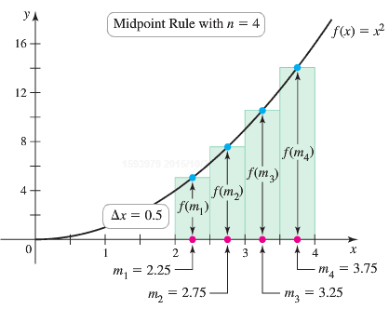





 

**Trapezoid Approximations**

The ***Trapezoid Rule*** for the value of a definite integral is based on approximating the region between a curve and the *x*-axis with trapezoids instead of rectangles.

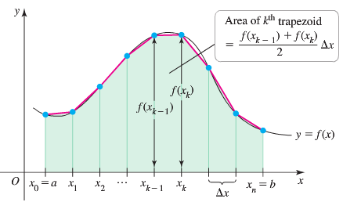

The length of each subinterval is  is called the ***step size*** or ***mesh size***.

The area of a trapezoid: 

The area is the approximation by adding the areas of all trapezoids:







***The Trapezoid Rule***

If  is continuous on [*a, b*] and if a regular partition of [*a, b*] is determined by the numbers , then







Where  and 

***Error Estimate for the Trapezoidal Rule***

If *M* is a positive real number such that  for all *x* in [*a, b*], then the error involved in using the Trapezoidal Rule is not greater than 

***Example***

Use the Trapezoid Rule with *n* = 4 to estimate . Compare the estimate with the exact value.

***Solution***

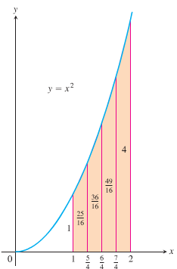

























 

The difference: 

The percentage error: 

***Simpson’s Rule*: Approximations Using Parabolas**

We partition the interval [*a, b*] into *n* subintervals of equal length 

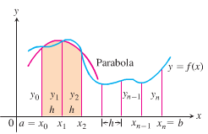 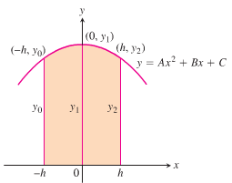

The parabola has an equation of the form: 

So the area under it from *x* = *−h* to *x* = *h* is













Since the curve passes through the three points 











Computing the areas under all the parabolas and adding the results gives the approximation





***Simpson’s Rule***

To approximate , use 



Where 



***Error Estimate for the Trapezoidal Rule***

If *M* is a positive real number such that  for all *x* in [*a, b*], then the error involved in using the Simpson’s Rule is not greater than 

***Example***

Use Simpson’s Rule with *n* = 4 to approximate 

***Solution***















 ***The exact value is* 32**.

***Example***

The table lists rates of change  in global sea level  in various years from 1995  to 2011 , with rates of change reported in *mm/yr*.

|  |  |  |  |  |  |  |  |  |
| --- | --- | --- | --- | --- | --- | --- | --- | --- |
| *Years* | 1995 | 1998 | 2000 | 2002 | 2003 | 2007 | 2009 | 2011 |
| ***t*** | 0 | 3 | 5 | 7 | 8 | 12 | 14 | 16 |
| (*mm/yr*) | 0.51 | 5.19 | 4.39 | 2.21 | 5.24 | 0.63 | 4.19 | 2.38 |

1. Assuming  is continuous on , explain how a definite integral can be used to find the net change in sea level from 1995 to 2011; then write the definite integral.
2. Use the data in the table and generalize the trapezoid Rule to estimate the value of the integral from part (*a*).

***Solution***

1. The net charge in any quantity *Q* over the interval  is 

Net change in  

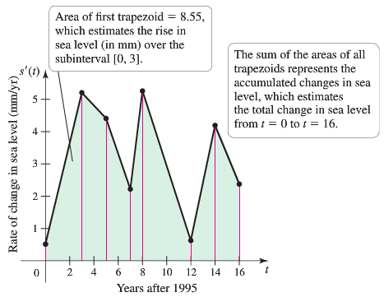

1. From the figure the values accompanied by 7 trapezoids whose area approximates 

***Area*** of the ***first*** trapezoid: 















***Exercises*** ***Section* 2.5 – Numerical Integration**

Find the *Midpoint* Rule approximations to

|  |  |
| --- | --- |
|  |  |

Estimate the minimum number of subintervals to approximate the integrals with an error of magnitude of  by (***a***) the *Trapezoid* Rule and (***b***) *Simpson’s* Rule.

|  |  |  |
| --- | --- | --- |
|  |  |  |

Find the *Trapezoid* & *Simpson’s* Rule approximations and error to

|  |  |
| --- | --- |
|  |  |

1. A piece of wood paneling must be cut in the shape shown below. The coordinates of several point on its curved surface are also shown (with units of inches).

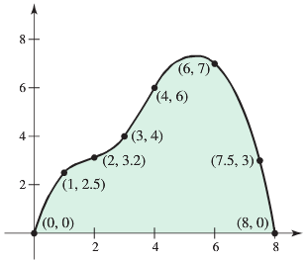

1. Estimate the surface area of the paneling using the Trapezoid Rule
2. Estimate the surface area of the paneling using a left Riemann sum.
3. Could two identical pieces be cut from a 9-in by 9-in piece of wood?

***Section* 2.6 – Improper Integrals**

***Definition***

Integrals with infinite limits of integration are ***improper integrals***.

|  |  |
| --- | --- |
| 1. If  is continuous on , then |  |
| 1. If  is continuous on , then |  |
| 1. If  is continuous on , then |  |

In each case, if the limit is finite we say that the improper integral ***converges*** and that the limit is the ***value*** of the improper integral. If the limit fails to exist, the improper integral ***diverges***.

***Example***

Is the area under the curve  from *x* = 1 to *x* = ∞ finite? If so, what is its value?

***Solution***

|  |  |
| --- | --- |
|  |  |











 ***L’Hôpital Rule***





***Example***

Evaluate 

***Solution***









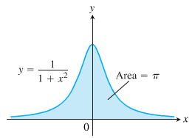 



















***Example***

For what value of *p* does the integral  converge? When the integral does converge, what is its value?

***Solution***

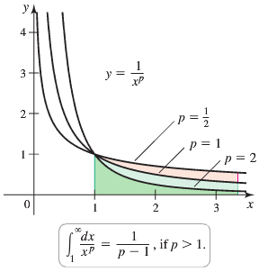If   







If  









**Integrands with Vertical Asymptotes**

***Definition***

Integrals of functions that become infinite at a point within the interval of integration are ***improper integrals***.

If the limit is finite we say that the improper integral ***converges*** and that the limit is the ***value*** of the improper integral. If the limit does not exist, the integral ***diverges***.

|  |  |
| --- | --- |
| 1. If  is continuous on , then |  |
| 1. If  is continuous on , then |  |
| 1. If  is continuous on , then |  |

***Example***

Investigate the convergence of 

***Solution***









The limit is infinite, so the integral diverges.

***Example***

Evaluate 

***Solution***

The integrand has a vertical asymptote at *x* = 1 and is continuous on [0, 1) and (1, 3].











***Example***

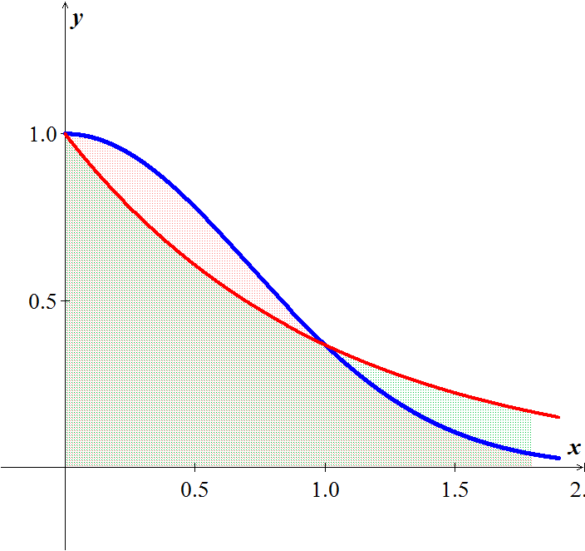Does the integral  converge?

***Solution***





The integral converges

***Theorem* − Direct Comparison Test**

Let  and  be continuous on [*a*, ∞) with  for all . Then

1. 
2. 

***Theorem* − Limit Comparison Test**

If the positive functions  and  are continuous on [*a*, ∞), and if



Then



Both converge or both diverge

***Example***

Show that  converges by comparison with . Find and compare the two integral values.

***Solution***

The functions  and  are positive and continuous on [1, ∞). Also,







Therefore,  converges because  converges.

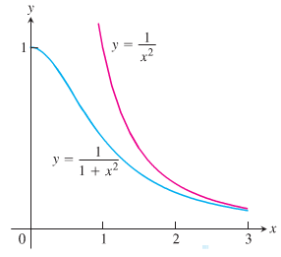







***Example***

Let *R* be the region bounded by the graph of  and the , for .

1. What is the volume of the solid generated when *R* is revolved about the ?
2. What is the surface area of the solid generated when *R* is revolved about the ?
3. 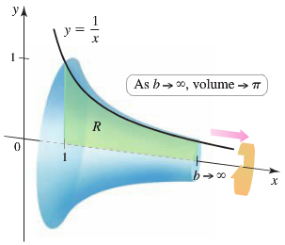What is the volume of the solid generated when *R* is revolved about the ?

***Solution***

1.  







1.  











1.  





***Exercises*** ***Section* 2.6 – Improper Integrals**

Evaluate the integrals

|  |  |  |  |  |  |
| --- | --- | --- | --- | --- | --- |
|  | |  | |  | |
|  | |  | |  | |

Find the area of the unbounded shaded region

|  |  |
| --- | --- |
|  |  |
|  |  |

1. Find the area of the region *R* between the graph of  and the on the interval  (if it exists)
2. Find the volume of the region bounded by  and the  on the interval  is revolved about the .
3. Find the volume of the region bounded by  and the  on the interval  is revolved about the .
4. Find the volume of the region bounded by  and the  on the interval  is revolved about the .
5. Find the volume of the region bounded by  and the  on the interval  is revolved about the .
6. Find the volume of the region bounded by  and the  on the interval  is revolved about the .
7. Find the volume of the region bounded by  and the  on the interval  is revolved about the .
8. Find the volume of the region bounded by  and the  on the interval  is revolved about the .
9. Find the volume of the region bounded by  and the  on the interval  is revolved about the .
10. Find the volume of the solid generated by revolving the region bounded by the graphs of , , and  about the .

Consider the region satisfying the inequalities

1. Find the area of the region
2. Find the volume of the solid generated by revolving the region about the .
3. Find the volume of the solid generated by revolving the region about the .

|  |  |
| --- | --- |
|  |  |

1. Find the perimeter of the hypocycloid of four cusps 
2. Find the arc length of the graph  over the interval 
3. The region bounded by  is revolved about the to form a torus. Find the surface area of the torus.
4. Find the surface area formed by revolving the graph  on the interval  about the 
5. The magnetic potential *P* at a point on the axis of a circular coil is given by



Where *N, I, r, k*, and *c* are constants. Find *P*.

1. A “semi-infinite” uniform rod occupies the nonnegative . The rod has a linear density *δ*, which means that a segment of length  has a mass of . A particle of mass *M* is located at the point . The gravitational force *F* that the rod exerts on the mass is given by



Where *G* is the gravitational constant. Find *F*.

1. Let *R* be the region bounded by the graph of  and the 
2. Let *S* be the solid generated when *R* is revolved about the . For what values of *p* is the volume of *S* finite for ?
3. Let *S* be the solid generated when *R* is revolved about the . For what values of *p* is the volume of *S* finite for ?
4. Let *S* be the solid generated when *R* is revolved about the . For what values of *p* is the volume of *S* finite for ?
5. Let *S* be the solid generated when *R* is revolved about the . For what values of *p* is the volume of *S* finite for ?
6. The solid formed by revolving (about the ) the unbounded region lying between the graph of  and the   is called ***Gabriel’s Horn***.



Show that this solid has a finite volume and an infinite surface area

1. Water is drained from a 3000-*gal* tank at a rate that starts at 100 *gal/hr*. and decreases continuously by 5% /*hr*. If the drain left open indefinitely, how much water drains from the tank? Can a full tank be emptied at this rate?

***First Order Differential Equations***

***Section* 2.7 – First-Order Linear Equations**

**General First-Order Differential Equations and Solutions**

A ***first-order differential equation*** is an equation



In which  is a function of two variables defined on a region in the *xy*-plane.

***Example***

Show that every member of the family of functions  is a solution of the first-order differential equation  on the interval (0, ∞), where C is any constant.

***Solution***













 **√**

Therefore, for every value of C, the function  is a solution of the first-order differential equation .

***Example***

Show that the function  is a solution of the first-order initial value problem .

***Solution***

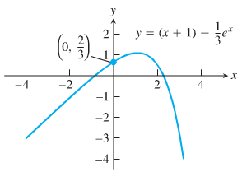













***Slope Fields*: Viewing Solution Curves**

Each time we specify an initial condition  for the solution of a differential equation , the solution curve is required to pass through the point  and to have a slope  there.

What we draw a lineal element at each point  with slope  then the collection of these lineal elements is called a ***direction field*** or a ***slope field*** of the differential equation.

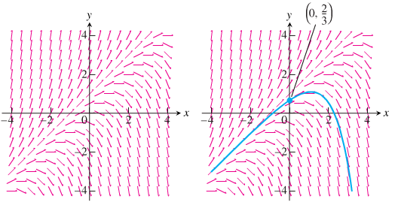

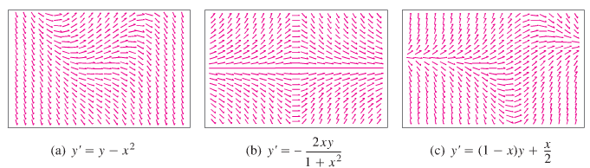

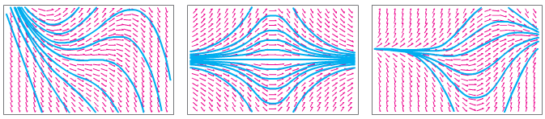

***Euler’s Method***

***Euler's method*** named after *Leonhard Euler* is an example of a ***fixed-step*** solver.

Euler's method is a first-order numerical procedure for solving ordinary differential equations (ODEs) with a given initial value. It is the most basic kind of explicit method for numerical integration of ordinary differential equations.

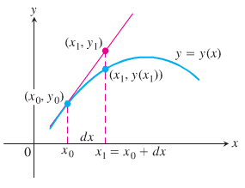 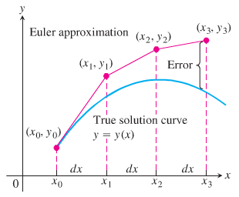

 

The setting size: 

Then, 





*Last point* 

By the definition of the derivative:





The tangent line at the point  is:





This method is known as *Euler's Method* with step size *h*.

***Example***

Find the first three approximations  using Euler’s method for the initial value problem



Starting at  with *dx* = 0.1.

***Solution***

























***Example***

Use Euler’s method to solve



On the interval , starting at  and taking

1. *dx* = 0.1.
2. *dx* = 0.05.

Compare the approximations with the values of the exact solution 

***Solution***

1. Euler Method ***dx* = 0.1**

***t Approx. Exact Difference***

----------------------------------------------------------------

0.00 | 1.00000000 | 1.00000000 | 0.00000000

0.10 | 1.20000000 | 1.21034184 | 0.01034184

0.20 | 1.42000000 | 1.44280552 | 0.02280552

0.30 | 1.66200000 | 1.69971762 | 0.03771762

0.40 | 1.92820000 | 1.98364940 | 0.05544940

0.50 | 2.22102000 | 2.29744254 | 0.07642254

0.60 | 2.54312200 | 2.64423760 | 0.10111560

0.70 | 2.89743420 | 3.02750541 | 0.13007121

0.80 | 3.28717762 | 3.45108186 | 0.16390424

0.90 | 3.71589538 | 3.91920622 | 0.20331084

1.00 | 4.18748492 | 4.43656366 | 0.24907874

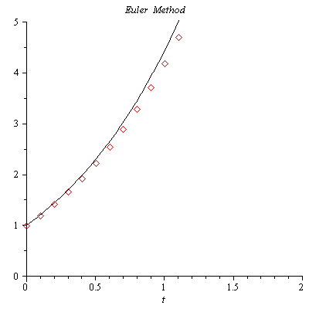

1. Euler Method ***dx* = 0.05**

***t Approx. Exact Difference***

----------------------------------------------------------------

0.00 | 1.00000000 | 1.00000000 | 0.00000000

0.05 | 1.10000000 | 1.10254219 | 0.00254219

0.10 | 1.20500000 | 1.21034184 | 0.00534184

0.15 | 1.31525000 | 1.32366849 | 0.00841849

0.20 | 1.43101250 | 1.44280552 | 0.01179302

0.25 | 1.55256313 | 1.56805083 | 0.01548771

0.30 | 1.68019128 | 1.69971762 | 0.01952633

0.35 | 1.81420085 | 1.83813510 | 0.02393425

0.40 | 1.95491089 | 1.98364940 | 0.02873851

0.45 | 2.10265643 | 2.13662437 | 0.03396794

0.50 | 2.25778925 | 2.29744254 | 0.03965329

0.55 | 2.42067872 | 2.46650604 | 0.04582732

0.60 | 2.59171265 | 2.64423760 | 0.05252495

0.65 | 2.77129828 | 2.83108166 | 0.05978337

0.70 | 2.95986320 | 3.02750541 | 0.06764222

0.75 | 3.15785636 | 3.23400003 | 0.07614367

0.80 | 3.36574918 | 3.45108186 | 0.08533268

0.85 | 3.58403664 | 3.67929370 | 0.09525707

0.90 | 3.81323847 | 3.91920622 | 0.10596775

0.95 | 4.05390039 | 4.17141932 | 0.11751893

1.00 | 4.30659541 | 4.43656366 | 0.12996825

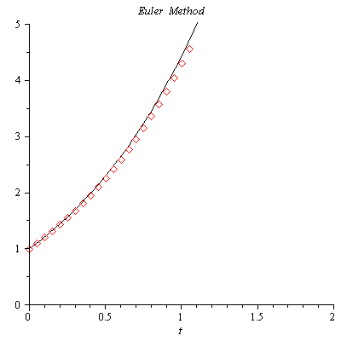

A ***first-order linear*** differential equation is one that can be written in the ***standard form***



Where *P* and *Q* are continuous functions of *x*

**Solving Linear Equations**

We solve the equation 

**Separable Equation**

***Solution of the homogenous equation***





 ***Integrate both sides***

 ***Convert to exponential form***





***Example***

Solve the differential equation 

***Solution***









 *Cross multiplication*



***General Method***

1. Separate the variables
2. Integrate both sides
3. Solve for the solution , if possible

***Example***

Find the general solution of the differential equation. 

***Solution***



 









***Solution of the Nonhomogeneous Equation ***

Let assume:  

The homogeneous equation is given by 











 *Since* 





















***Example***

Solve the equation 

***Solution***













***Example***

Solve the equation , satisfying 

***Solution***





|  |  |
| --- | --- |
|  |  |







 



***Exercises Section* 2.7 – First-Order Linear Equations**

Write an equivalent first-order differential equation and initial condition for *y*.

|  |  |
| --- | --- |
|  |  |

Use Euler’s method to calculate the first three approximations to the given initial value problem for the specified increment size. Calculate the exact solution and investigate the accuracy of your approximations. Round the results to four decimals

|  |  |
| --- | --- |
|  |  |

1. Use the Euler method with  to estimate  if  and . What is the exact value of ?

Verify that the given function *y* is a solution of the differential equation that follows it. Assume that  are arbitrary constants.

1. 
2. 
3. 
4. 
5. 
6. 
7. 

Verify that the given function *y* is a solution of the initial value problem that follows it.

1. 
2. 
3. 
4. 

Solve the differential equations

|  |  |
| --- | --- |
|  |  |

Solve the initial value problem

|  |  |
| --- | --- |
|  |  |

***Section* 2.8 – Applications**

**Motion with Resistance Proportional to Velocity**

An object with a mass ***m*** is moving along a coordinate line with position function ***s*** and velocity ***v*** at time ***t***.

From ***Newton’s second law*** of motion, the resistance force opposing the motion is



If the resisting force is proportional to velocity, we have



This is a separable differential equation, the solution with initial condition  is



In the English system, where the weight is measured in pounds, mass is measured in slugs. Thus,



***Example***

For a 192-*lb* ice skater, the ***k*** is about  slug/sec and . How long will it take the skater to coast from 11 *ft/sec* (7.5 *mph*) to 1 *ft/sec*? How far will the skater coast before coming to a complete stop?

***Solution***

 









Distance 

**Mixtures Problems**

The physical representation of the rate of change:

*rate of change = rate in* - *rate out*

This is referred to as a ***balance law***.

Rate = Volume Rate (*gal/min*) *x* Concentration (*lb/gal*)

If  is the amount of chemical in the container at time *t* and  is the total volume of liquid in the container at time *t*, then the departure rate of the chemical at time *t* is





***Example***

In an oil refinery, a storage tank contains 2000 *gal* of gasoline that initially has 100 *lb*. of an additive dissolved in it. In preparation for winter weather, gasoline containing 2 *lb*. of additive per gallon is pumped into the tank at a rate of 40 *gal/min*. The well-mixed solution is pumped out at a rate of 45 *gal/min*. How much of the additive is in the tank 20 *min* after the pumping process begins?

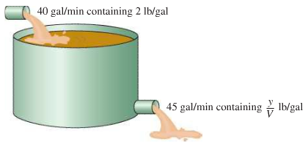

***Solution***

Let *y* be the amount (in *lb*.) of additive in the tank at time *t* and 

















 

































**RL Circuits**

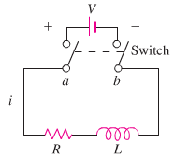

The diagram represents an electrical circuit whose total resistance is a constant ***R*** ohms and whose self-inductance is coil, is ***L*** henries.

***Ohm’s Law***: 



***i***: current in amperes

***t***: time in seconds

***Example***

The switch in the *RL* circuit is closed at time *t* = 0. How will the current flow as a function of time?

***Solution***

























The current approaches the ***steady-state value*** .

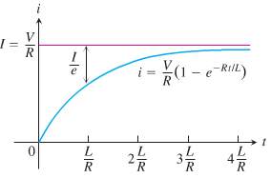

***Exercises Section* 2.8 – Applications**

1. A 66-*kg* cyclist on a 7-*kg* bicycle starts coasting on level ground at 9 *m/sec*. The 
2. About how far will the cyclist coast before reaching a complete stop?
3. How long will it take the cyclist’s speed to drop to 1 *m/sec*?
4. Suppose that an Iowa class battleship has mass 51,000 metric tons (51,000,000 *kg*) and . Assume that the ship loses power when it is moving at a speed of 9 *m/sec*.
5. About how far will the ship coast before it is dead in the water?
6. About how long will it take the ship’s speed to drop to 1 *m/sec*?
7. A 200-*gal* tank is half full of distilled water. At time *t* = 0, a solution containing 0.5 *lb./gal* of concentrate enters the tank at the rate of 5 *gal/min*, and the well-stirred mixture is withdrawn at the rate of 3 *gal/min*.
8. At what time will the tank be full?
9. At the time the tank is full, how many pounds of concentrate will it contain?
10. A tank contains 100 *gal* of fresh water. A solution containing 1 *lb./gal* of soluble lawn fertilizer runs into the tank at the rate of 1 *gal/min*, and the mixture is pumped out of the tank at a rate of 3 *gal/min*. Find the maximum amount of fertilizer in the tank and the time required to reach the maximum.
11. An Executive conference room of a corporation contains 4500  of air initially free of carbon monoxide. Starting at time *t* = 0, cigarette smoke containing 4% carbon monoxide is blown into the room at the rate of 0.3 . A ceiling fan keeps the air in the room well circulated and the air leaves the room at the same rate of 0.3 . Find the time when the concentration of carbon monoxide in the room reaches 0.01%.
12. Many chemical reactions are the result of the interaction of 2 molecules that undergo a change to produce a new product. The rate of the reaction typically depends on the concentrations of the two kinds of molecules. If *a* is the amount of substance *A* and *b* is the substance *B* at time *t* = 0, and if *x* is the amount of product at time *t*, then the rate of formation of *x* may be given by the differential equation



Where *k* is a constant for the reaction. Integrate both sides of this equation to obtain a relation between *x* and *t*.

1. If 
2. If 

Assume in each case that  when 

1. The tank initially holds 100 *gal* of pure water. At time , a solution containing 2 *lb* of salt per gallon begins to enter the tank at the rate of 3 gallons per minute. At the same time a drain is opened at the bottom of the tank so that the volume of solution in the tank remains constant.

How much salt is in the tank after 60 *min*?

What will be the eventual salt content in the tank?

1. The 600-*gal* tank is filled with 300 *gal* of pure water. A spigot is opened above the tank and a salt solution containing 1.5 *lb*. of salt per gallon of solution begins flowing into the tank at the rate of 3 *gal/min*. Simultaneously, a drain is opened at the bottom of the tank allowing the solution to leave tank at a rate of 1 *gal/min*. What will be the salt content in the tank at the precise moment that the volume of solution in the tank is equal to the tank's capacity (600 *gal*)?
2. The amount of drug in the blood of a patient (in *mg*) due to an intravenous line is governed by the initial value problem



Where *t* is measured in hours

1. Find and graph the solution of the initial value problem.
2. What is the steady-state level of the drug?
3. When does the drug level reach 90% of the steady-state value?
4. A fish hatchery has 500 *fish* at time , when harvesting begins at a rate of *b* *fish/yr*. where . The fish population is modeled by the initial value problem.



Where *t* is measured in years.

1. Find the fish population for  in terms of the harvesting rate *b*.
2. Graph the solution in the case that . Describe the solution.
3. Graph the solution in the case that . Describe the solution.
4. A community of hares on an island has a population of 50 when observations begin at . The population for  is modeled by the initial value problem.



1. Find the solution of the initial value problem.
2. What is the steady-state population?
3. When an infected person is introduced into a closed and otherwise healthy community, the number of people who become infected with the disease (in the absence of any intervention) may be modeled by the logistic equation



Where *k* is a positive infection rate, *A* is the number of people in the community, and  is the number of infected people at . The model assumes no recovery or intervention.

1. Find the solution of the initial value problem in terms of *k*, *A*, and .
2. Graph the solution in the case that  .
3. For fixed values of *k* and *A*, describe the long-term behavior of the solutions for any  with 
4. An object in free fall may be modeled by assuming that the only forces at work are the gravitational force and resistance (friction due to the medium in which the objects falls). By Newton’s second law (mass × acceleration = the sum of the external forces), the velocity of the object satisfies the differential equation



Where  is a function that models the resistance and the positive direction is downward. One common assumption (often used for motion in air) is that , where  is a drag coefficient.

1. Show that the equation can be written in the form  where 
2. For what (positive) value of *v* is  (This equilibrium solution is called the ***terminal velocity***.)
3. Find the solution of this separable equation assuming  for 
4. Graph the solution found in part (***c***) with , and verify the terminal velocity agrees with the value found in part (***b***).
5. An open cylindrical tank initially filled with water drains through a hole in the bottom of the tank according to Torricelli’s Law. If  is the depth of water in the tank for , then Torricelli’s Law implies  , where *k* is a constant that includes the acceleration due to gravity, the radius of the tank, and the radius of the drain. Assume that the initial depth of the water is 

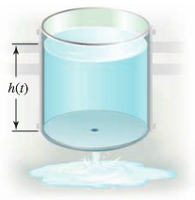

1. Find the solution of the initial value problem.
2. Find the solution in the case that  and .
3. In general, how long does it take the tank to drain in terms of *k* and *H*?
4. The reaction of chemical compounds can often be modeled by differential equations. Let  be the concentration of a substance in reaction for  (typical units of *y* are *moles/L*). The change in the concentration of a substance, under appropriate conditions, is , where  is a rate constant and the positive integer *n* is the order of the reaction.
5. Show that for a first-order reaction , the concentration obeys an exponential decay law.
6. Solve the initial value problem for a second-order reaction  assuming 
7. Graph and compare the concentration for a first-order and second-order reaction with  and 
8. The growth of cancer turmors may be modeled by the Gomperts growth equation. Let  be the mass of the tumor for . The relevant intial value problem is



Where *a* and *K* are positive constants and 

1. Graph the growth rate function  assuming  and . For what values of *M* is the growth rate positive? For what values of *M* is maximum?
2. Solve the initial value problem and graph the solution for , , and . Describe the growth pattern of the tumor. Is the growth unbounded? If not, what is the limiting size of the tumor?
3. In the general equation, what is the meaning of *K*?
4. An endowment is an investment account in which the balance ideally remains constant and withdrawals are made on the interest earned by the account. Such an account may be modeled by the initial value problem  for , with . The constant *a* reflects the annual interest rate, *m* is the annual rate of withdrawal, and is the initial balance in the account.
5. Solve the initial value problem with  and . Does the balance in the account increase or decrease?
6. If  and , what is the annual withdrawal rate *m* that ensures a constant balance in the account? What is the constant balance?
7. The halibut fishery has been modeled by the differential equation 

Where  is the biomass (the total mass of the members of the population) in kilograms at time *t* (measured in years), the carrying capacity is estimated to be  and .

1. If , find the biomass a year later.
2. How long will it take for the biomass to reach .
3. Suppose a population  satisfies  where *t* is measured in *years*.
4. What is the carrying capacity?
5. What is ?
6. When will the population reach 50% of the carrying capacity?
7. Let  be the performance level of someone learning a skill as a function of the training time *t*. The graph of *P* is called a ***learning curve***. We proposed the differential equation



As a reasonable model for learning, where *k* is a positive constant. Solve it as a linear differential equation and use your solution to graph the learning curve.

1. 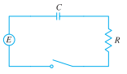A circuit containing an electromotive force, a capacitor with a capacitance of *C* farads (*F*), and a resistor with a resistance of *R* ohms . The voltage drop across the capacitor is , where *Q* is the charge (in coulombs), so in this case ***Kirchhoff’s Law*** gives



But , so we have 

Find the charge and the current at time *t*

1. Suppose the resistance is , the capacitance is 0.05 *F*, a battery gives voltage of 60 *V* and initial charge is 
2. Suppose the resistance is , the capacitance is 0.01 *F*,  and initial charge is 
3. A 30−volt electromotive force is applied to an *LR*-series circuit in which the inductance is 0.1 *henry* and the resistance is 50 *ohms*.
4. Find the current  if 
5. Determine the current as 
6. Solve the equation when  and 
7. A tank contains 50 *gallons* of a solution composed of 90% water and 10% alcohol. A second solution containing 50% water and 50% alcohol is added to the tank at the rate of . As the second solution is being added, the tank is being drained at a rate of . The solution in the tank is stirred constantly. How much alcohol is in the tank after 10 *minutes*?



1. A 200-*gallon* tank is half full of distilled water. At time , a concentrate solution containing  enters the tank at the rate of , and well-stirred mixture is withdrawn at the rate of .
2. At what time will the tank be full?
3. At the time the tank is full, how many pounds of concentrate will it contain?



1. A 200-*gallon* tank is half full of distilled water. At time , a concentrate solution containing  enters the tank at the rate of , and well-stirred mixture is withdrawn at the rate of .
2. At what time will the tank be full?
3. At the time the tank is full, how many pounds of concentrate will it contain?



1. A 200-*gallon* tank is full of a concentrate solution containing . Starting at time , distilled water is admitted to the tank at the rate of , and well-stirred mixture is withdrawn at the same rate.
2. Find the amount of concentrate in the solution as a function of *t*.
3. Find the time at which the amount of concentrate in the tank reaches 15 pounds.
4. Find the quantity of the concentrate in the solution as .

